“Digital youth work”

Long term training course on exploring and inventing digital youth work methods and tools in order to support the youth participation and activism of culturally diverse young people based on the impact of COVID19

7 – 16 July 2022, Manchester, United Kingdom

Themes of the long-term training course:
Raising digital competences of youth workers to activate participation of youth online.
Inventing youth work methods and tools in order to empower online participation and activism of culturally diverse youth such as minorities, refugees, migrants and Rome young people.
To create and practice safe digital participation tools for young people based on the impact of COVID19.

The overall aim of the long-term training course is to improve the digital competences of youth workers, youth leaders being able to support culturally disadvantaged young people regarding to the topics of youth participation, analysis of the level of youth participation in their communities, tools and fields of online youth participation, tackling the role of Internet literacy for online youth participation and online activism based on the impact of COVID19.

The project is a long-term training course. It has three phases:

Phase I: 1st training course on online participation and activism of young people especially having diverse cultural background based on the impact of COVID19.
7 – 14 April 2022, Sfântu Gheorghe, Romania

Phase II: Practice period May-August 2022 with the local actions on online participation will be made by participants on support the online activism of culturally diverse young people through youth work activities in local level based on the impact of COVID19.
Phase III: 2nd training course on e-democracy and youth participation in decision making online based on the impact of COVID19
7-16 July 2022, Manchester, United Kingdom

Learning objectives of the training course are:
- To increase critical thinking and internet literacy of youth workers in order to build a safe space for participation online for young people with special focus on having culturally diverse background such as minorities, refugees, migrants, Roma, etc.;
- To develop a shared understanding of youth participation online and analyse the achievements and pitfalls of current youth participation in these processes based on the impact of COVID19 in youth work;
- To explore what are the rights and the opportunities and the support required by young people in order to meaningfully participate in the shaping of the Internet.
- To share and explore youth work methods and tools to engage young people online and develop their capacity and competences in active participation in the life of community after COVID19.

The methodology of the long-term training course:
The project will be based on non-formal educational methodology. A variety of non-formal learning methods and techniques will be applied in order to address the different needs of participants and desired outcomes.
It will include the following elements: e-learning prior the training course, getting-to-know each other and building common group; understanding the main concepts and issues (youth participation, the level of youth participation in the communities of participants online and offline, media literacy), equipping with the tools of youth participation online (civic activism tools, e-governance tools), planning local initiatives and the youth exchange projects, evaluation of the long term training course.

Who can participate in the long-term training course:
- Youth workers, youth leaders who directly work with young people with fewer opportunities especially with refugees and migrants’ background, minorities, Roma, etc.;
- Youth workers, youth leaders who plan to improve their digital competences for supporting safe and meaningful online participation of young people based on the impact of COVID19;
- Ready to take part in the whole training course;
- To be able to communicate English language.

Eligible countries:
Romania, Hungary, Estonia, Greece, Italy, Lithuania, Serbia and United Kingdom

Applicant organisation:
Beat Bazaar Projects provides creative and cultural projects & experiences for young people and the community. We deliver projects and workshops in music making, digital arts and media. We develop high quality cultural events and festivals. We offer international training opportunities, pathways into the creative and cultural industries and valuable industry experience. We support musicians, artists and creatives to find their journey through the arts and meet their full potential.

Financial conditions:
United Kingdom: 0 euros / participant
Hungary: 360 euros / participant
Estonia: 275 euros / participant
Greece: 360 euros / participant
Italy: 275 euros / participant
Lithuania: 275 euros / participant
Serbia: 275 euros / participant
Romania: 360 euros / participant

Participants: 4 / country

Please find the application form below, fill them in by the date of 20/06/2022 and send it to the following email address: boroka@beatbazaar.org.uk!
If you have any further questions, do not hesitate to contact us!
Greetings,

PERSONAL DATA a a
First name:
Family name:
Nationality:
Date of birth:
(dd/mm/yyyy)
Gender:
Complete address:
Postal code:
Town:
Country
Phone number:
E-mail:
Size of T-shirt:
Do you have any special needs or requirements that the host organisation should know about? (E.g. mobility, medical needs, allergies, dietary restrictions, smoker/non-smoker)

Please indicate us the name and full contact details of a person to be contacted in case of emergency during the seminar:
First name:
Family name:
Complete address:
Postal code:
Town:
Country
Phone number:
Fax:
E-mail:
Web:

Venue:

LIMELIGHT

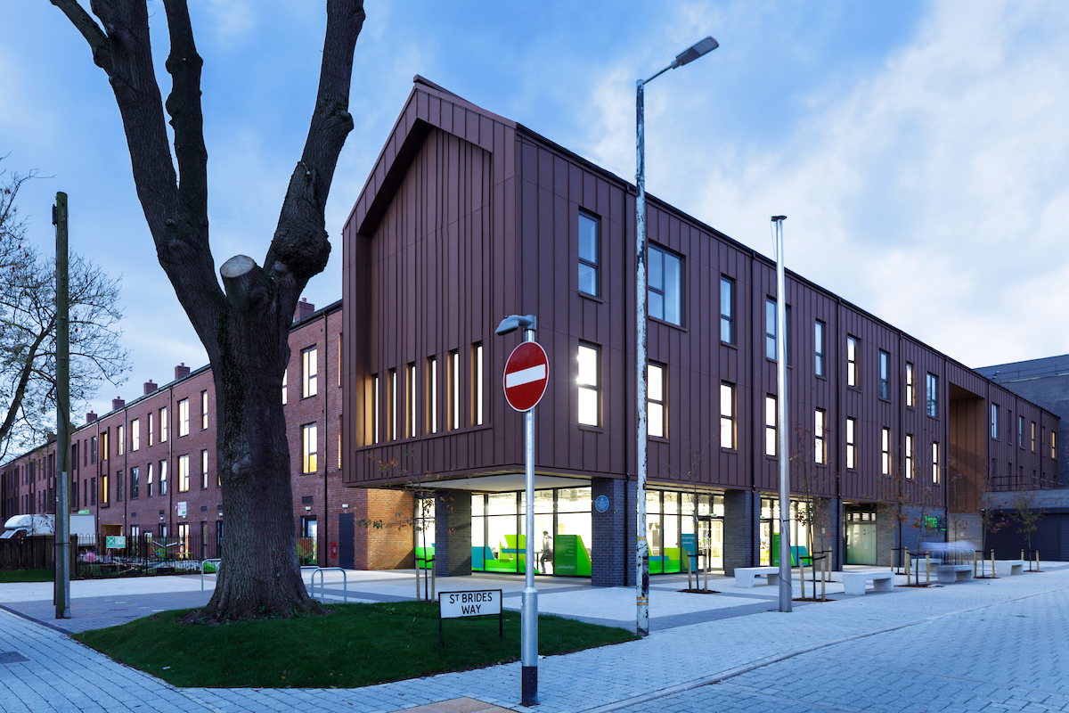

Address: Old Trafford, Manchester, Post Code: M16 9NW
Accommodation:

TRAVELODGE- SALFORD QUAYS
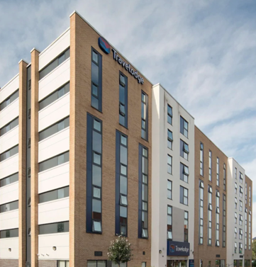

Address: 18 Markendale Place, Salford M5 3GW

